Retirement

- No Work (for the time being)

- Overwhelming sense of loss

- No Work (for the remainder of my life)

- Nothing has changed!

- Increasing experience of loss

Then I heard a voice from heaven saying to me, “Write: ‘Blessed are the dead who die in the Lord from now on.’” “Yes,” says the Spirit, “that they may rest from their labors, and their works follow them.”
REVELATION 14:13

Therefore they are before the throne of God, and serve Him day and night in His temple. And He who sits on the throne will dwell among them.
REVELATION 7:15

Faithful-Fruitful

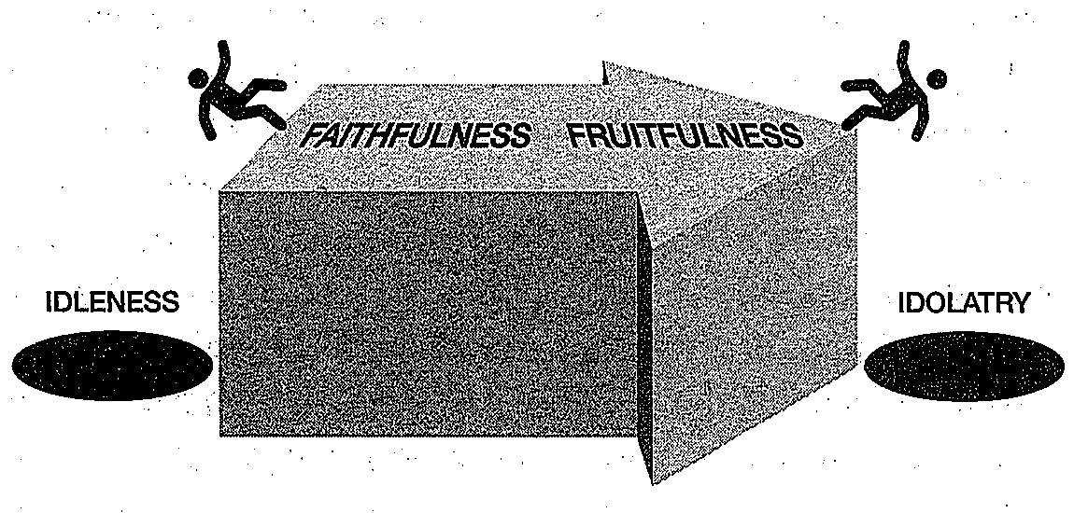
[1] Family

[2] Church

[3] Work

[4] Parents (Extended Family)

Some Practical Steps We Can Take

In the area of ________________________:

- What Does It Mean To Be Faithful (According To The Bible)?

- Am I Faithful (According To The Bible)?

- Where Have I Fallen?

- How Can I Be Fruitful?

Bear In Mind . . .

- And let our people also learn to maintain good works, to meet urgent needs, that they may not be unfruitful (TITUS 3:14)

- For He knows our frame; He remembers that we are dust (PSALM 103:14)

- But his lord answered and said to him, ‘You wicked and lazy servant . . . (MATTHEW 25:26)

